A LIVING ARCHITECTURE BASE
Executive summary — two pages
We have turned the output of one engagement into a reusable, structured base, and built a system that interrogates our experts to fill what is missing. Documents are now generated from that base rather than written from a previous document. We are asking for a second engagement to prove it.

The problem
Every engagement produces a substantial architecture document, and six months later almost none of the thinking inside it is retrievable. Three consequences cost us money.
- Knowledge is re-created — the next engagement starts from a copy of the last document and inherits its mistakes along with its structure. Corrections made once are not propagated.
- Proposals over-claim — nothing distinguishes a capability we have delivered from one we intend to build, so the distinction gets made for us by an evaluation committee.
- Estimates carry no evidence — no engagement records what the work actually took, and integration surprises surface in delivery rather than in framing.

What we built
Three things, of which the first two are in service.
- A structured base — principles, decisions with their rejected alternatives, reusable patterns, vendor due-diligence questionnaires, effort models and risk registers — small, versioned, reviewed. Forty-five of them today, from one engagement.
- Generated documents — a document is now a projection of that base plus the specifics of the engagement, produced in passes with a human decision between each. Its most valuable output is not the prose but the list of gaps produced before drafting: what we do not know, what the client has not told us, which vendor answers we are quietly assuming.
- Gap-driven elicitation — rather than waiting for contributions, the system detects what is missing and asks the right expert a precise question, carrying what a previous engagement answered so that they confirm or diverge. Disagreements between experts are surfaced and arbitrated with a written reason, instead of discovered in acceptance testing.

What it changes
 | Today, without it | With it
Reuse | Copy a previous document and edit | Confirm or diverge from what was answered before; the divergence is the work
Proposals | Claims rest on the author's judgement | Every claim carries an evidence level; anything aspirational is reworded or dropped before review
Estimates | A range with no history | A range with variance drivers and, from the second engagement, actuals
Disagreements | Settled verbally, rarely recorded | Recorded, arbitrated with a rationale, and the rejected option survives in the document

When it pays
Not on the first engagement. Going first is expensive: everything is written from scratch and the effort model has no history. The return begins on the second, when questions arrive pre-filled, only divergences require thought, and the model receives its first real figures.
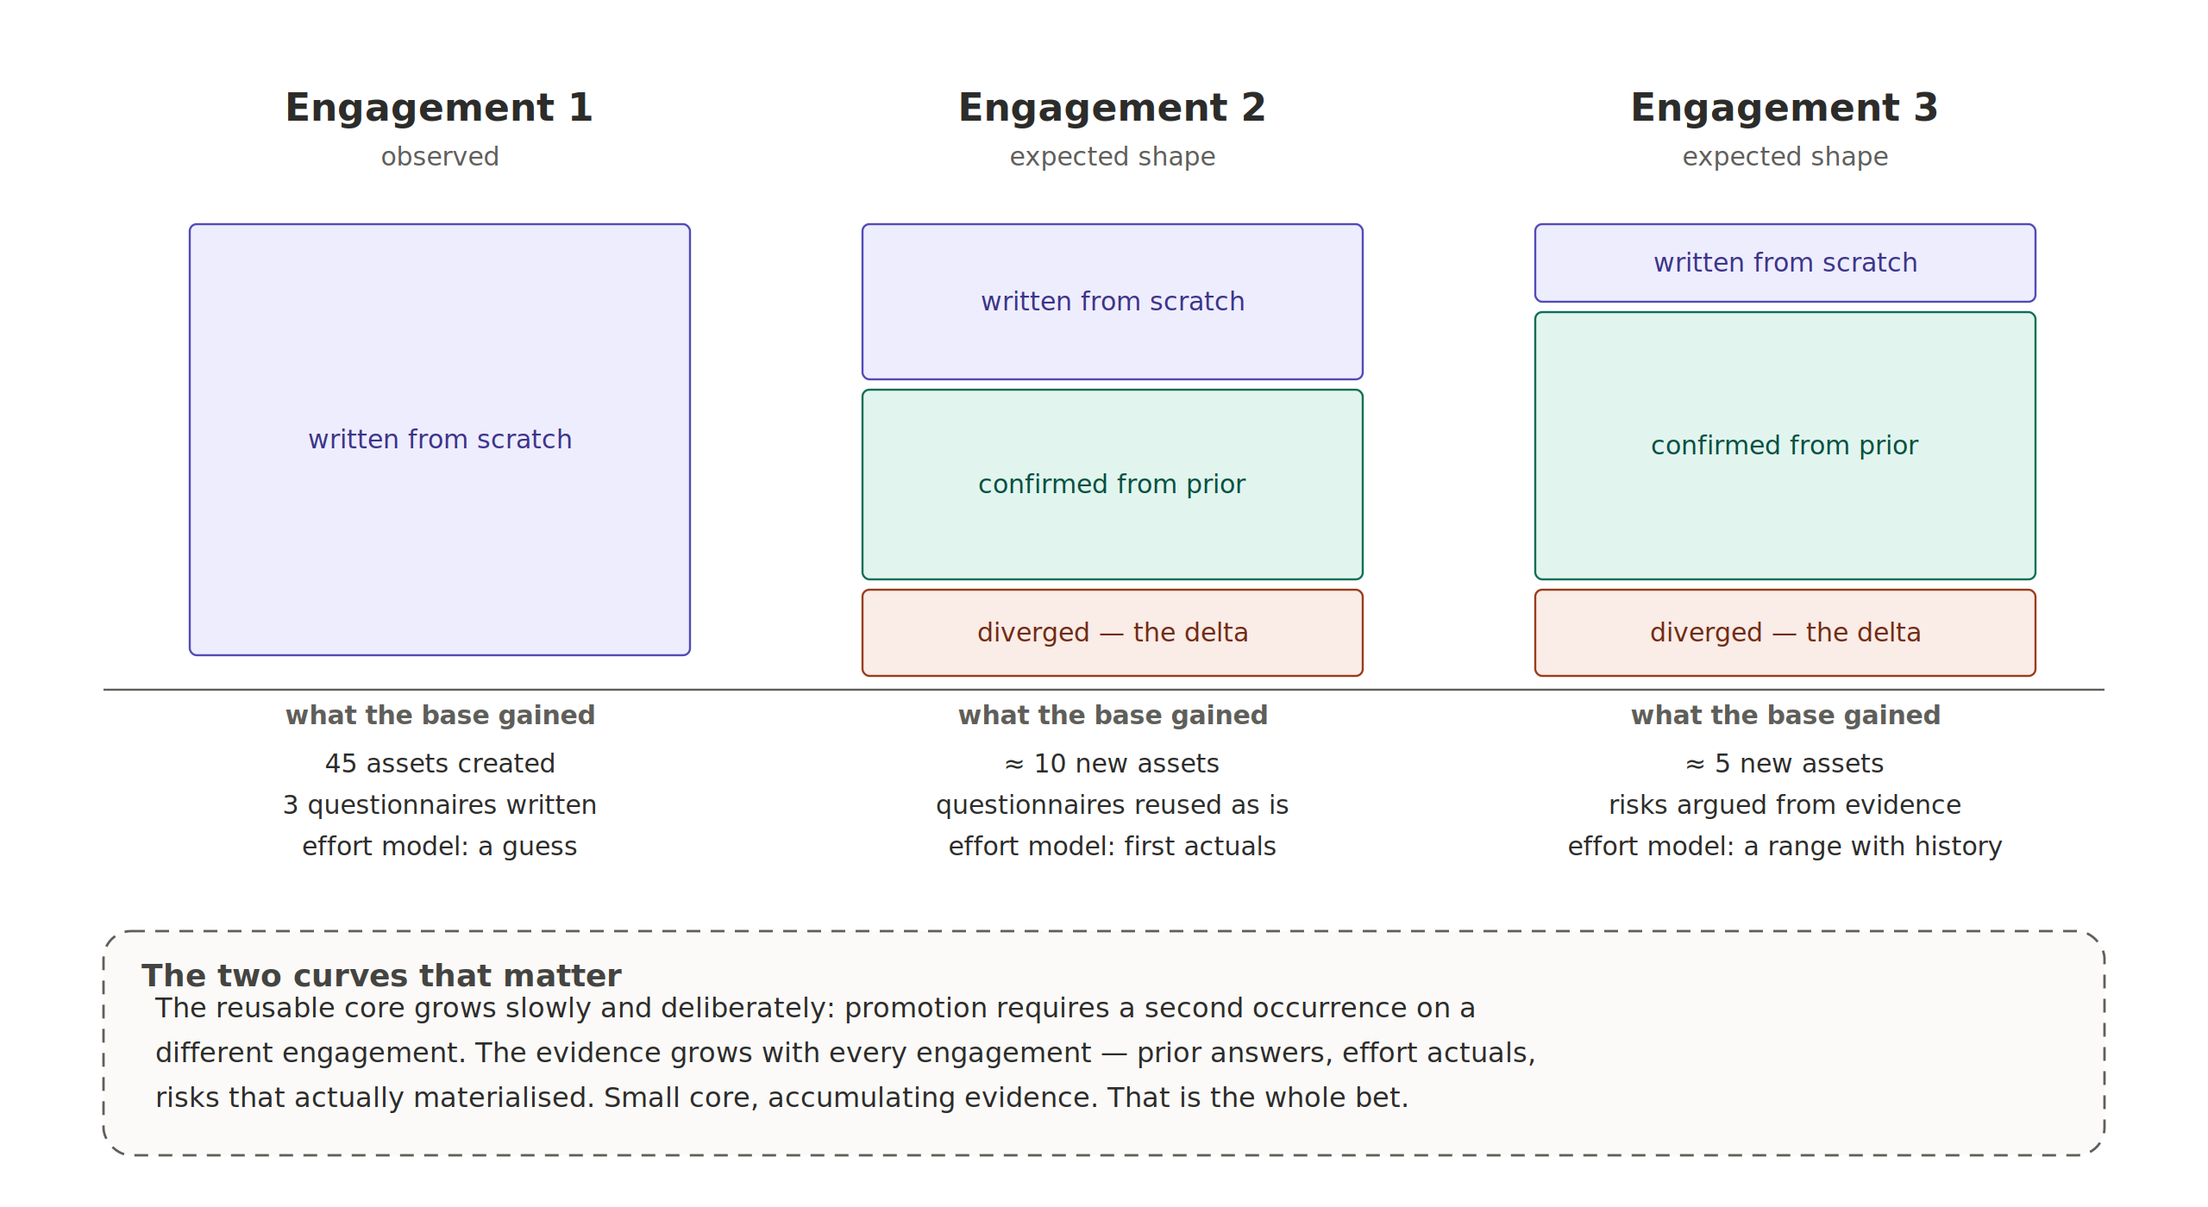
The first column is observed. The second and third are the expected shape, and remain a hypothesis until a second engagement tests it.

What we are asking for
- One engagement to run it a second time — the cost is roughly two hours to describe the engagement, and the first useful output — the list of what we do not yet know — comes before anything is drafted.
- Two named owners — one architect per domain to review changes to the shared base, and one chief architect per engagement to arbitrate. Neither is a new job; both are a few hours a month.
- A half-day per phase — a short review at the end of each phase, recording what the effort actually was and which risks materialised. It is the only input no amount of architecture thinking can produce, and the one most likely to be skipped.

What we are not claiming
This does not automate architecture. The system retrieves, structures, drafts, checks and asks; judgement about what to promise, defer or refuse stays with the architect. Three limits, stated before someone finds them: the growth curve above is a hypothesis until a second engagement tests it; the coherence checking will raise false alarms and miss real problems, which is why it advises and never blocks; and the base dies quietly if the end-of-phase review is skipped — a management risk, not a technical one.
The base currently holds the reasoning of a single engagement. It becomes shared knowledge on the second — which is the decision we are asking for.

